# UCTlogo No shadow

# INF3014F: Responsive Web Design

**Tutorial 4**

Due Date: Friday 15th March 2024 @ 23:59 PM.   
Total = 50 marks

# Instructions

In this tutorial, you will use Responsive Web Design. This means creating designs that adapt to different screen sizes and devices, such as mobile phones and tablets. A responsive design uses CSS media queries to adjust the layout and content of a webpage based on the screen size of the device being used. Apply the below tasks to your newly minted Fashion and Retail Store website in Tutorial 3.

On Windows OS, use Notepad (or Notepad++) to code the web pages and TextEdit for those with MacOS, and use any browser to view and test your web pages. To start, create a new text document on your desktop and rename it to **home.html**. **You can also use other IDEs like Visual Studio, Sublime or VS Code. However, do follow the instructions below when submitting.**

# Tasks:

## Responsive Web Design

1. Open and review the existing Fashion and Retail Store website that you created in Tutorial 3.
2. Add a meta viewport tag to your HTML file. This tag tells the browser how to adjust the page's dimensions and scaling to match the screen size of the device. Add this code to the head section of your HTML file:

<meta name="viewport" content="width=device-width, initial-scale=1">

1. Add CSS media queries to adjust the layout and content of your webpage for different screen sizes. You can specify different CSS rules for different screen widths, using the ‘media’ rule. For example, to adjust the layout for smaller screens, you might add a rule like this:

@media only screen and (max-width: 600px) {

/* CSS rules for screens smaller than 600px */

}

1. Use relative units for sizing, such as percentages or ems, rather than fixed pixels. This allows the design to adapt to different screen sizes.
2. Test your website across different devices and browsers to ensure that it displays correctly and is user-friendly. Use the Google Chrome Inspector Tool to test and simulate 3 different devices (Mobile device, Tablet, Desktop). See link: <https://docs.inductiveautomation.com/display/DOC80/Test+Your+Responsive+Design+Using+Chrome%27s+Developer+Tools>

Submit this Tutorial under *Assignments (Tutorial 4)* on Vula.

**Finished!**

# Grading Rubric (Evaluation Criteria):

Responsive Web Design

| **Criteria** | **Marks** |
| --- | --- |
| All HTML and CSS elements are converted and displayed correctly on mobile and desktop devices | 10 |
| Errors in HTML and CSS conversion | 5 |
| Responsive Web Design Implementation | 5 |
| Website layout and content is responsive and adjusts to different screen sizes | 15 |
| Proper use of CSS media queries | 5 |
| Navigation menu is responsive and easy to use and the use of Use of custom CSS styles and/or images that enhance the design | 5 |
| Font sizes and spacing are adjusted for optimal readability on mobile devices | 5 |
| Total | 50 |

**PLEASE NOTE THAT YOU ARE REQUIRED TO USE YOUR OWN DESIGN HENCE THERE ARE NO DESIGN TEMPLATES. MAKE SURE TO BE CREATIVE.**

* Add consistent comments in your code. It helps clarify the purpose and functionality of the code for both yourself and the tutors who will review the code.
* Make sure all HTML files and images should be within one main folder.
* Save your files (i.e., images, etc.) with the correct file extensions, and zip your folder before submission!
* **Zip all files into one folder and submit them on Vula.**

Plagiarism Declaration

**Disclaimer: AI code generation and completion**

We acknowledge the existence of numerous AI code generation and completion tools that are currently available. However, we strongly advise against using these tools due to their potential negative impact on the learning experience. These tools tend to diminish the opportunity for individuals to develop their coding skills and problem-solving abilities. Therefore, it is highly recommended to avoid relying on AI code generation and completion tools, especially for those who are just starting to learn how to code. It is crucial to take the time to understand coding concepts and principles and practice writing code from scratch to develop one's coding skills fully.

YOU ARE WARNED TO TAKE PLAGIARISM VERY SERIOUSLY – WE DEFINITELY WILL!

A mark of 0 will be given for any submission, including copying from other resources without referencing it.

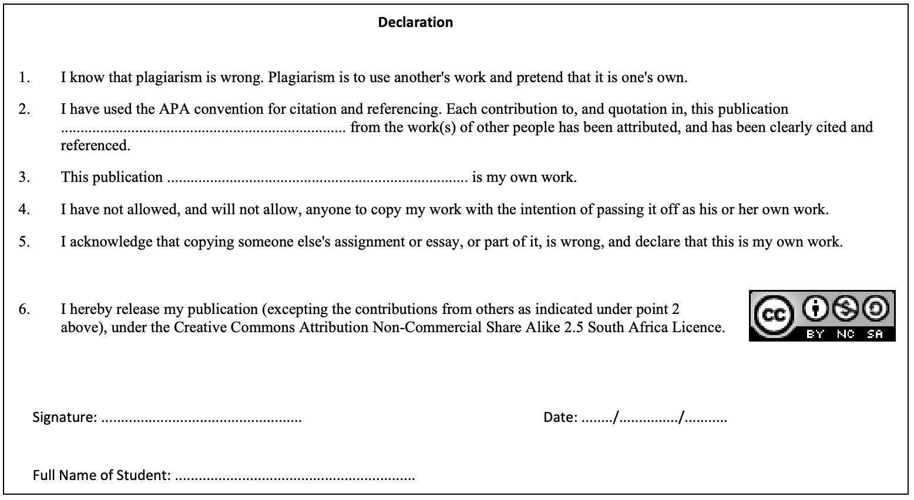

Additional Resources:

* How to use Chrome Inspector Tool:
* Chrome Inspector Tool is a powerful tool that can be used to test the user-friendliness of a website across different devices. Here's how you can use it:
* Open your website in Google Chrome and right-click on any element on the page.
* Select "Inspect" from the menu that appears. This will open the Chrome Inspector Tool.
* Click on the device icon in the top left corner of the Inspector Tool. This will open the Device Toolbar.
* From the Device Toolbar, you can select different devices and orientations to test how your website looks and behaves on those devices.
* You can also simulate different network conditions and user locations to test the website's performance under different circumstances.
* As you make changes to your website's design and layout, you can use the Device Toolbar to test how those changes look and function on different devices.
* You can also use the Inspector Tool to debug any issues that arise during testing.
* See W3Schools for more information: <https://www.w3schools.com/html/html_responsive.asp>

<https://www.w3schools.com/css/css_rwd_intro.asp>

-------oo000oo--------